The Messages to the Seven Churches
Life application

- The Church in Ephesus: The loveless church
“I hold this against you: You have forsaken your first love.” Revelation 2:4.
- The Church in Smyrna: The persecuted church
“Be faithful, even to the point of death, and I will give you the crown of life.” Revelation 2:10.
- The Church in Pergamum: The compromising church
“I have a few things against you, because you have there those who hold the doctrine of Balaam, who taught Balak to put a stumbling block before the children of Israel, to eat things sacrificed to idols, and to commit sexual immorality.” Revelation 2:14.
- The Church in Thyatira: The corrupt church
“I have this against you: You tolerate that woman Jezebel, who calls herself a prophetess.” Revelation 2:20.
- The Church in Sardis: The dead church
“I know your works that you have a name that you are alive, but you are dead. Be watchful; and strengthen what remains and is about to die, for I have not found your deeds complete in the sight of my God.” Revelation 3:1-2.
- The Church in Philadelphia: The faithful church
“I know your deeds. See, I have placed before you an open door that no one can close. I know that you have little strength, yet you have kept my word and have not denied my name.” Revelation 3:8.
- The Church in Laodicea: The lukewarm church
“I know your works, that you are neither cold nor hot. I could wish you were cold or hot. So then, because you are lukewarm, and neither cold nor hot, will I vomit you out of my mouth.” Revelation 3:15-16.

Church | Commendation | Criticism | Instruction | Promise
Ephesus  Rev. 2:1-7 | Rejects evil, perseveres, has patience | Love for Christ no longer fervent | Do the works done at church’s beginning | The tree of life
Smyrna  Rev. 2:8-11 | Gracefully bears suffering | None | Be faithful until death | The crown of life
Pergamum  Rev. 2:12-17 | Keep the faith of Christ | Tolerates immorality, idolatry & heresies | Repent | Hidden manna and a stone with a new name
Thyatira  Rev. 2:18-29 | Love, service, faith, and patience are greater than at first | Tolerates cult of idolatry and immorality | Judgment is coming, keep the faith | Rules over nations and receives morning star
Sardis  Rev. 3:1-6 | Some have kept the faith | A dead church | Repent, strengthen what remains | Faithful will be honored and clothed in white
Philadelphia  Rev. 3:7-13 | Perseveres in the faith, keeps the word of Christ, honors His name | None | Keep the faith | A place in God’s presence, a new name, and the new Jerusalem
Laodicea | None | Indifferent | Be zealous and repent | Share Christ’s throne

The Message to the Seven Churches
Introduction
- Who are the angels (Greek for “messenger”) of the 7 Churches? They are either real angels or the Priests/Bishops of these churches/cities, but it does not really matter because the message remains the same.
- What is a church? It is a body of believers. The building is where the body of the believers meets.
  - Romans 16:3-5 “3 Greet Priscilla and Aquila, my fellow workers in Christ Jesus, 4 who risked their own necks for my life, to whom not only I give thanks, but also all the churches of the Gentiles. 5 Likewise, greet the church that is in their house…..”
  - Colos 4:15 “15 Greet the brethren who are in Laodicea, and Nymphas and the church that is in his house.16 Now when this epistle is read among you, see that it is read also in the church of the Laodiceans, and that you likewise read the epistle from Laodicea.”
  - Philemon 1:1-2 “To Philemon our beloved friend and fellow laborer, 2 to the beloved Apphia, Archippus our fellow soldier, and to the church in your house…”

- Who did Christ invite to hear the messages to the churches?
Rev 2:7 “He who has an ear, let him hear what the Spirit says to the churches…”

- Anything discussed in this study can be applied to the church (the body of the believers) or our homes (the church made of our family) or us personally (the church presented in our own body which is the temple of the Holy Spirit).
However, it is best to start with the church that is in our own bodies.

- This study is not an open invitation to criticize or condemn. When we talk about the dead church or the compromising church, we are talking about a person or a congregation; we are not talking about the priest, the servants, or the bishop only. They can be at fault too. If the believers are healthy spiritually, they can revive dead priests, servants, or bishops. The opposite is true too.
- You will see that God had told the angel of each church “a custom-tailored message.” Nothing was generic or one-size fits all. The message was highly specific addressing a specific problem. The examples God gave related to the church’s culture, geographic location, industry, etc.
Pray that God speaks specifically to you today.

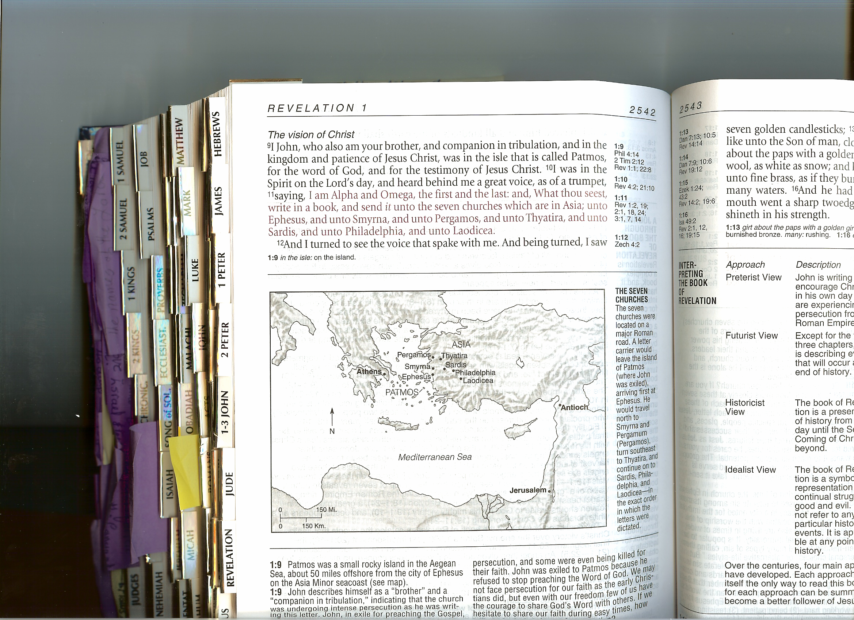

The Church in Ephesus
The Loveless Church: Rev 2:1-7
Historians and scholars agree that John the Beloved was the bishop/priest of the church of Ephesus. You must understand that it would have been painful and hard on him to learn that his church had forsaken its first love!
Commendation: vv. 2-3 - good works, labored for Christ’s name, persevered, and patient, among others.
Criticism: v. 4 - you forsook your first love.
- Could be first as a point of time (Your love as of last year or 10 years ago)
- Or could be first as priority of love (God became 2nd , 3rd, or 10th)
Forsake, “Aphiemie” in Greek means giving up or letting go of something or forgiving.
Jesus used it twice in the Lord’s prayer (Forgive us our sins as we forgive those ...)
Sometimes we forsake our first love because we refuse to let go of our harsh feelings, forget the problem, or forgive a person (spouse, a child, a coworker, a friend, etc.). We end up losing our first love to this person and our first love to God.
Instruction: Search from where you fell and repent. To grow closer to God we have to be active. We will not get anywhere in our personal and spiritual lives without putting time and effort into it.
We need to examine ourselves always to see what our shortcomings are and try to correct that. This will help us improve our relationship with God and everyone else.
Promise: Eat from the tree of life in the middle of paradise. What does that mean?
Gen 2:8-9 & 3:22:
- Renewed fellowship with God
- Intimacy with God ( walk and talk with God as Adam and Eve before their fall)
- And have a full access to God; what Adam and Eve lost after falling

The Church in Smyrna (modern day Izmar Turkey)
The Persecuted Church: Rev 2:8-11
Smyrna was a seaport known for its beautiful seascape. It was very advanced in science and medicine, and had a huge Roman cult and a large Jewish population. The cult and the Jewish population made life very difficult for the new church and the believers. In spite of that, it is one of only 2 churches not criticized by Christ.
Commendation: vv. 8-9 and consolation v. 10 “Do not fear any of those things which you are about to suffer ….”
Bad things happen to good people not to punish them, but to edify them, strengthen their faith, and to prepare them to receive the crown of life.
Criticism: None
How marvelous! We come and stand before Christ and He does not have a single critical word for us, how wonderful is that? Not because we are sinless, but because we are guiltless. We lived and walked in His shadow and followed His footsteps. We fall; we get up, and follow Him. This is the road to a guiltless life.
Instruction: Be faithful to the end.
Promise: Crown of life. It is the same as the victory garland (modern day trophy) athletes used to receive in the Olympic Games at that time.
Life is a race/competition pursuing and continuing the life of faithfulness.

The Church in Pergamum (Pergamos)
The Compromising Church: 2:12-17
Pergamum was a cultural, athletic, and legal center that housed an imposing gymnasium, a theater, and the 2nd largest library in the world, at that time, after the library in Alexandria.
**When news about this library reached Egypt, a papyrus importer stopped all shipments of papyrus to Pergamos. This led to the development of parchment paper (Grek. Pergemena) made from animal skin, and hence the name of the city.
A side note: when we are hateful and jealous and do not wish people to be as successful or prosperous as us, sometimes God allows them to become better than us! Trust that God is capable of granting success to everyone, without compromising your success.
Commendation: good works, did not deny His name or their faith even during persecution.
Criticism: v. 14 - I have few things against you
- Tolerate wrong teaching and heresies
Wrong teaching can be as deadly as heresies. Do not settle for only one source of information and teaching. Read, search, analyze, listen to different teachers, and above all pray for wisdom and the spirit of discernment to know the truth form heresy.
^{“11}Now these (Bereans) were more noble-minded than those in Thessalonica, for they received the word with great eagerness, examining the Scriptures daily to see whether these things were so.” Acts 17:11.
The Bereans were making sure that what Paul was telling them was correct and true.
- Eat what is sacrificed to idols (they had many pagan feasts where they sacrificed to idols).
In the name of sharing with our friends, family, and neighbors we sacrifice our standard and do what they do, even if it was spiritually incorrect.
- Sexual immorality. Most of us will say definitely I do not do that.
Immoral sex or adultery is obvious sin that most of us do not do. The deadly sexual immoralities we commit, all of us, are the little things that we do and do not even acknowledge it as sin.
Satan would love that everyone thinks that he is this ugly creature with the horns and tail, because you will never find this creature anywhere to avoid! It is a fictional character. Satan is alive and well and he is so smooth and does his thing cunningly. Be careful of what you read, watch on TV, or listen to. It could be full of sexual immorality.
Instructions: Repent (Action).
Promise:
- Eat the hidden manna. Instead of eating what is sacrificed to idols, God will shower us with His Glory, the manna, and we will have a share in Him, the bread of life, who was sacrificed for us. You’ll have both physical and eternal spiritual food.
- A white stone
  - Pergamos was a legal center: When a person was in a trial and found innocent, he used to get a white stone with his name written on it. If he was found guilty, the stone was throne out.
  - And an athletic center: Winning athletes used to receive a white stone instead of a trophy.
- A new name
A new name earned when you become a new creation in Christ as Abram/Abraham, Sari/Sarah or Simon/Peter. Or you will have the name of Christ attached to you, such as Christian, heir, son/daughter of Abraham, or son/daughter of the living God.

The Church in Thyatira
The Corrupt Church: 2:18-29
Thyatira was a commercial city and military headquarters.
Known for its wool, linen, leather, pottery and bronze-making (many scholars believe that is why Christ described His feet as made of brass v. 18).
Their coins had a metal worker& a military helmet on one side and a goddess on the other side.
Commendation: v. 19 - love, works, faith, and patience.
Criticism: A false prophetess (Jezebel), idolatry, and sexual immorality (like Pergamum).
Jezebel: either a woman in the church (most probably) or a reference to Jezebel in 1 Kings 16-21.
Influential women:
- Women tend to be very influential
- God intended it this way so we can have an impact on our children
- With women in the workplace, church, military, and at home we must examine two kinds of influences
Jezebel | Lydia: Acts 16:11-15 (Originally from Thyatira & lived in Philippi)
Strong, smart and influential | Strong, smart and influential
Pretended to be someone she was not | Lived the life God intended for her
Elevated herself to a level she did not deserve | Accepted Paul into her house and served him and his companions
Used her influence to seduce the believers | Used her influence to bring her house to Christ and serve the believers

We should be careful how we use our influence.
Instruction: Judgment is coming. Wake up and holdfast to what you have.
Promise:
Power over the nations: To reign with Christ.
To reign with Christ is the only way we can achieve the right level of power/influence God intended for us.
The morning star: Christ Himself.
The morning star is the’ planet Venus”, also called the “light bringer”. It is always seen before light breaks, at dawn, as a very bright star. Biblically it symbolizes Christ who brings light to people’s life and changes it from darkness to tight.

The Church in Sardis
The Dead Church: 3:1-6
All ruins now
It was known for a famous cemetery called “the cemetery of the 1000 dead.”
The name of the Bishop was Zosimus, the root name is Zoe = Life.
Commendation: Some have kept the faith and did not defile themselves.
Criticism: You have a name, you are alive but you are dead.
Coincidence? Nothing is coincidental in the Bible.
You have a name but you are dead.
Go to church, fast, maybe even serve: looks alive.
No personal relationship with God, superficial spiritual life, no fruits, no impact, no enthusiasm, apathy: characteristics of death.
A church becomes dead because the congregation is dead, not because the priest/bishop is dead. When the most active priest/bishop preaches to dead people (in the cemetery, for instance) he will never get results. A priest cannot raise people from death. Only God, upon our request and active participation, can raise us from the dead and give us live.
It’s our own responsibility to stay alive; we cannot blame anyone for our spiritual death.
What if the priests/bishops are not good? Educate yourself, read, search, analyze, and inquire. PUT forth some effort. The bottom line is we do not have an excuse.
Instruction: v 2 “Be watchful, and strengthen the things which remain, that are ready to die, for I have not found your works perfect before God.”
Romans 3:23 - “for all have sinned and fall short of the glory of God”
We still have a chance; do not waste it. Remember all your gifts, talents, and abilities and utilize them instead of letting them die, because they will!
Promise: v. 5
- Walk with me clothed in white garments: That is what the redeemed will wear in the Lord’s presence = FELLOWSHIP with the Lord.
Rev. 7:13-14 “Then one of the elders answered, saying to me, “Who are these arrayed in white robes, and where did they come from?” 14 And I said to him, “Sir, you know.” So he said to me, “These are the ones who come out of the great tribulation, and washed their robes and made them white in the blood of the Lamb.”
- …. And I will not blot out his name from the Book of life.
The book of life is the list of the eternally redeemed.
Ex 32:31-33 The Golden calf sin: “Then Moses returned to the LORD and said, “Oh, these people have committed a great sin, and have made for themselves a god of gold! 32 Yet now, if You will forgive their sin—but if not, I pray, blot me out of Your book which You have written.” 33 And the LORD said to Moses, “Whoever has sinned against Me, I will blot him out of My book.”
It is a serious business. Let us make sure our names are written in the book of life.

The Church in Philadelphia (Modern day Alasehir, Turkey)
The Faithful Church: Rev 3:7-13
Philadelphia = One who loves his brother
The city changed its name several times.
Commendation: good works, kept the word, have not defiled His name even though it had little strength.
Little strength: Little talent, physical ability, education, position, money, or power.
It did not really matter because: v. 8 – ““I know your works. See, I have set before you an open door, and no one can shut it …”
Remember the parable of the talents in Luke 18:16-19. God gives us and asks back according to our talent, strength, and ability.
There is no point in lamenting, He is not asking for the impossible. He is only asking for what you can deliver based on what He gave you. We consider it impossible because of our little faith and laziness. We also think that He wants us to do what others do, which might be impossible for us, but possible for them based on their talent and strength!

Criticism: NONE
V. 10 “…. and to know that I have loved you.”
Again, no criticism. Not only that, but also a confession of His love and the great feelings we experience because of our awareness/knowledge of it!
Instruction: Hold on tight to your crown.
What if it was “little strength?” Absolutely! Hold on tight to that crown.
Promise:
- Keep us from the trial: protects us from ourselves (pride and laziness) and the world.
- Pillar in His temple: although we might have little strength, we’ll be the sturdiest structure, a pillar.
In all ancient archeological sites pillars withstand the test of time. Even though the structure might be completely destroyed, you can see some pillars standing and marking the place of the structure.
Are we the sturdiest part of the structure? In our homes, families, church, work, neighborhood?
- New name: (Philadelphia changed its name frequently)
He will not call us poor, lame, ignorant, powerless, or whatever our little strength is. Rather, He will give us a new name that has all the HONOR “The name of My God and the city of My God, the new Jerusalem).
Also see the church of Pergamos Rev 2:17.

The Church in Laodicea

The Lukewarm Church: Rev 3:14-22

Laodicea was known for its medicine, textile industry especially wool, and limited water resources.
It was sandwiched between Hierapolis, which is known for its hot springs and its medicinal value, and Colossae, which was known for its sparkling cold water.

Commendation: NONE
How awful is that? Nothing was good in this church!

Criticism:
- Neither hot nor cold, I will vomit you out of My mouth
Hot water has its hygienic and medicinal values. Cold water is refreshing and has its some medicinal values as well, but lukewarm water is good for nothing.
We have to have something to believe in. We cannot please everyone, accept everything, and be indifferent to everything. We cannot hold the stick from the middle. We cannot be lukewarm.
- Arrogance: v. 17
We might be rich, well-dressed, well-educated, and well-connected on the outside. However, we might be poor, naked, miserable, and blind personally and spiritually.
We need to let go of the noise in our life to hear Christ’s knockings.
V. 18 - all that we need comes from Christ:
  - Fine gold: spiritual riches
  - White garments: redemption
  - Eye salve: Healing and spiritual sight
There is a big difference between being independent and being arrogant.
We cannot live in vacuum. We need our parent’s blessings, husband’s love, children’s respect, bosses’ approval, friends’ acceptance, believer’s fellowship, and neighbor’s company.
Instruction: Be zealous and repent.
Believe in something. Stand up for something. Take a stand. Be a doer instead of a watcher.
Promise: Sit with me on my throne.
Where true riches, power, and prestige are.

Bibliography
- Nelson Study Bible (NKJ).
- Life application study Bible (KJ).
- Beth Moore, LifeWay. Beloved Disciple. The Life and Ministry of John.

