9-ZEPHANIAH
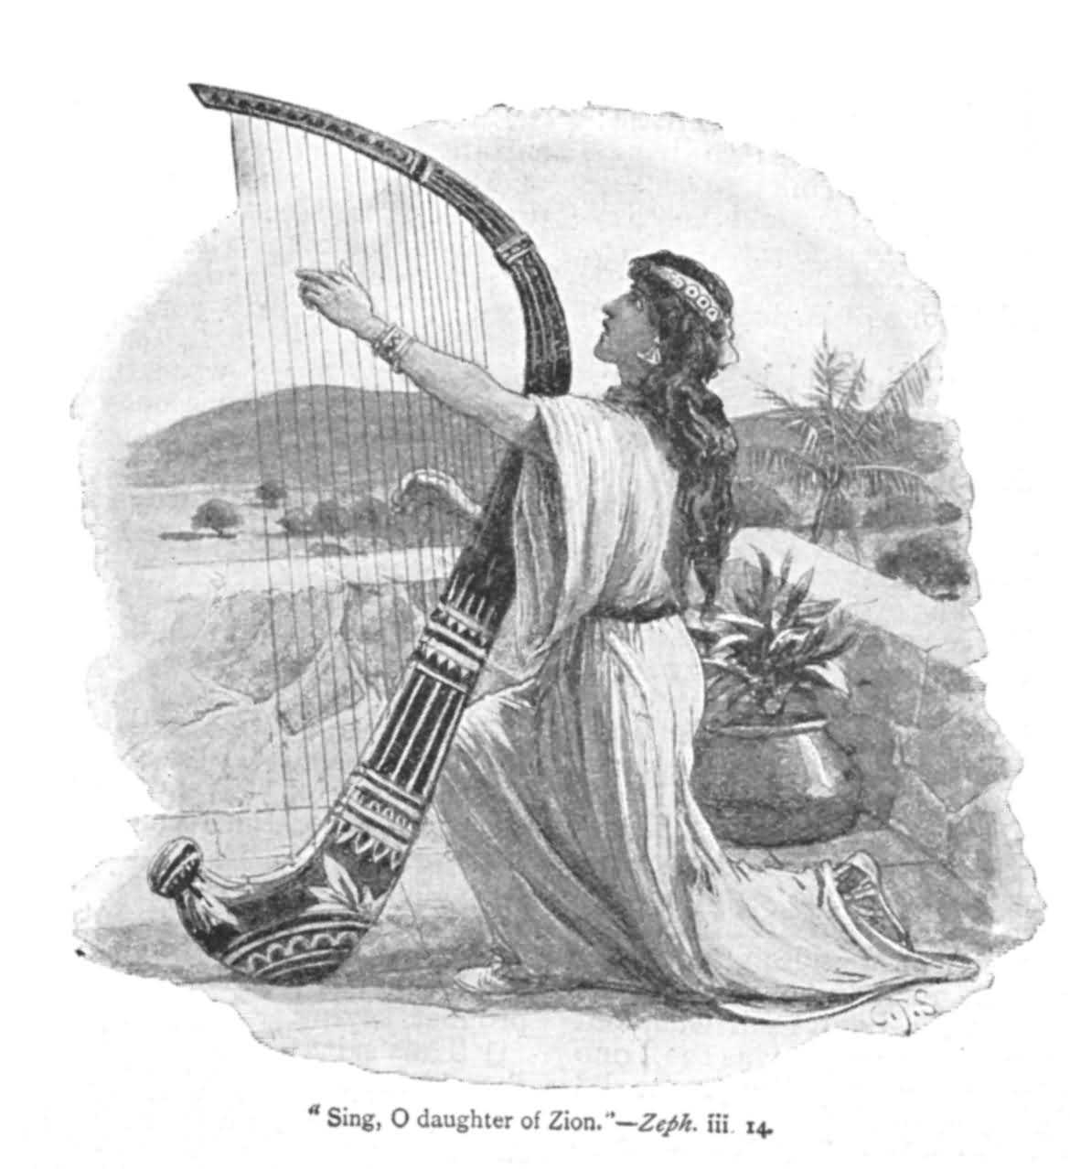

The theme of Zephaniah’s prophecies –the coming day of the Lord, the time of God’s judgment of the nations and his salvation of a remnant in Israel--- echoes in part the preaching of Amos and Isaiah.

AUTHOR AND HIS MESSAGE:
ZEPHANIAH :
    - Means Yahweh protects.
    - He was a descendant of Hezekiah, most likely King Hezekiah.
    - If he is of royal blood, he was a relative of King Josiah ( 640-609B.C.)
MESSAGE:
His prophecies unlike Amos , show no particular concern for the socially depressed classes , but criticize the national life of the top: the court officials, judges, the prophets priests , the foreign customs and the dress adopted by the wealthy persons ( 1:8)

THE BOOK:
The book falls into the following parts:
- The significance of the day of Yahweh for the world and for Judah ( 1:2-2:3)
- Its significance for foreign nations. ( 2:4-15)
- Its significance for Jerusalem ( 3:1-8 )
- Its significance for the righteous remnant. ( 3:9-20)

THEOLOGY AND INFLUENCE:
No prophet depicted more awesomely the terrors of God’s coming “ day of wrath” for the wicked in Judah and outside. Conversely , he stressed God’s mercy on the righteous remnant. Therefore , the thought moves between doom on the entire world , humaqn and animal included, versus the delights of salvation in a renewed world for those who escape doom.
No prophet said more potently than Zephaniah that God expects to deal decisively with evil men in this world and that the righteous are on the winning side.

Zephaniah is the last of the minor prophets before the 70 year captivity of Judah.

What is the good word?
“ The King of Israel , the Lord is in your midst ; you shall fear no evil no more.” Zep. 3:15

