4- OBADIAH

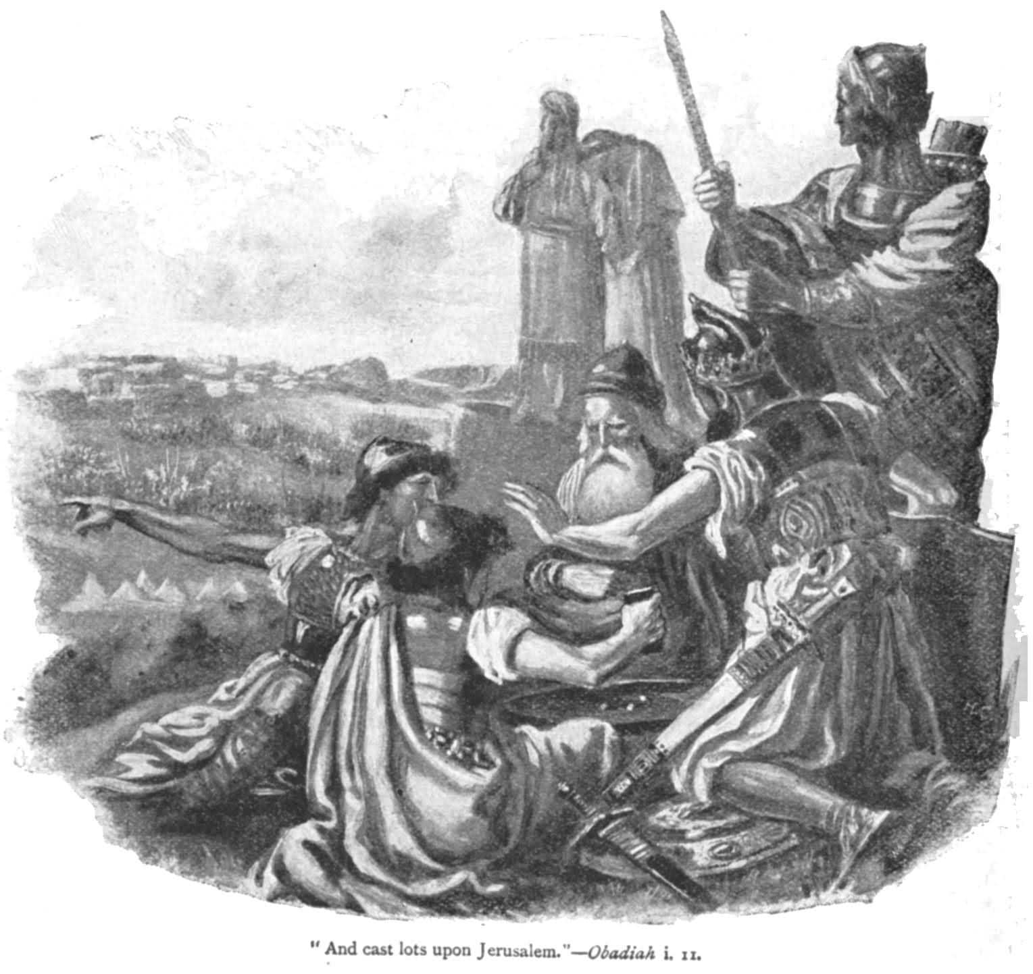

This is the shortest book in the Old Testament.

LIFE OF OBADIAH:
- Nothing is known of Obadiah whose name means simply “ Servant of Yahweh” , a name borne by nearly a dozen other Old Testament persons.
- It appears that he lived at the time of the fall of Jerusalem in 587 B.C. Some precise details ( vss.11-14) and the heat of his wrath against the country of Edom for their part in that event indicate that he was an eye witness of the fall.

TIME OF OBADIAH:
Edom’s basic sin was unbotherliness and uncaring in a time of misfortune. It failed to help Judah against its enemies. Not only this , but they gloated over their brother nation’s misfortune, looted at the time of destruction and captured and delivered to the enemy , fugitives from the stricken country.

Obadiah regarded this as strange and reprehensible. ( Esau , the father of the Edomites , was Jacob’s ( Israel ‘s ) twin – Gen.25:30 ; 36:1)

Obadiah called down the wrath of God on such betrayal. As the Edomites had done, so it be done to them. ( v.15). The coming “ day of the Lord” would even out the injustice.

Edom and other wicked nations would pass away, Israel would be saved.

INSIGHT:
Obadiah sounds like a nationalistic prophet of narrow and vengeful spirit. There is no forgiveness of enemies in what he said. He had however , a lively sense of justice and called on God to correct injustice in the great day of judgment.
Indeed ,Obadiah is the shortest book in the Old Testament, but it is long on judgment.

What is the good word:
“For the day of the LORD is near upon all the nations. As you have done, it shall be done to you, your deeds shall return on your own head.” Ob.1:15

