6- MICAH
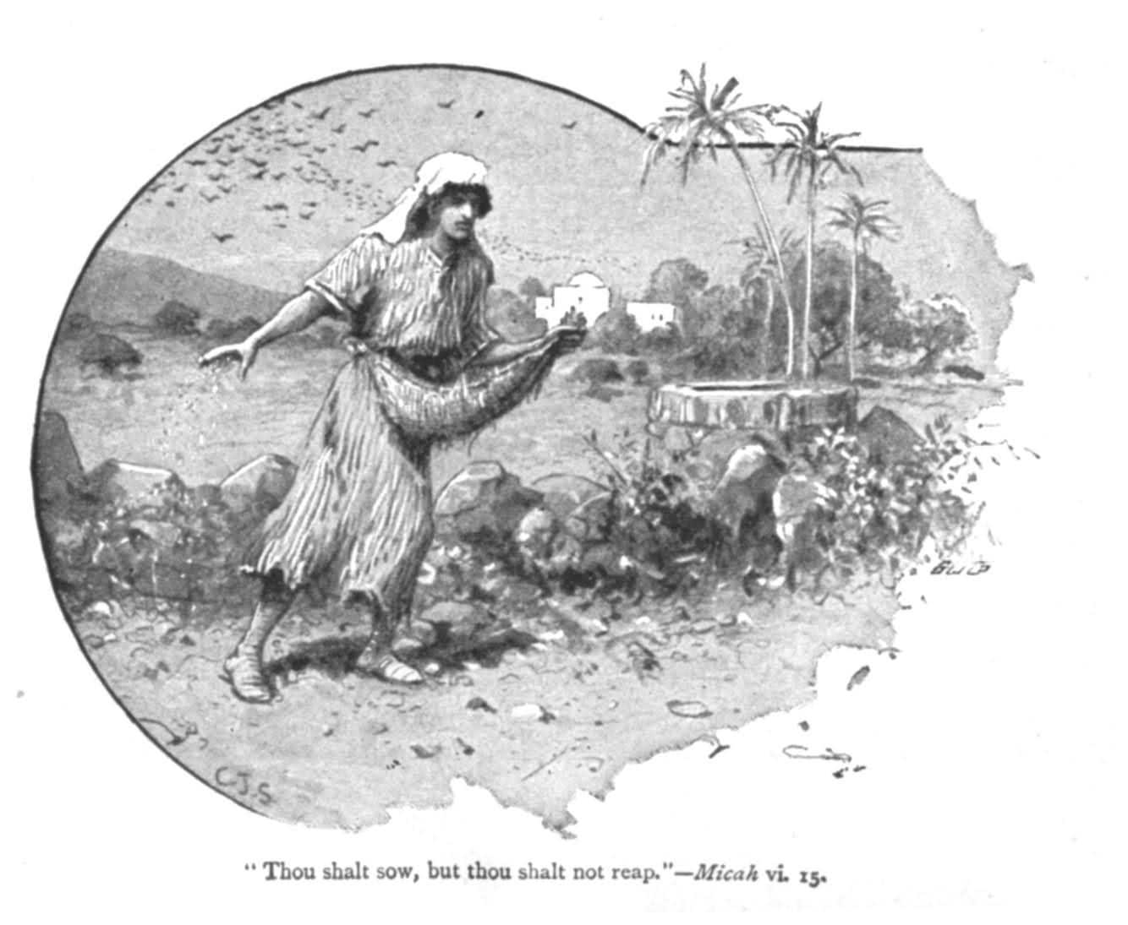

I-NAME , PLACE AND DATE:
- Micah is an abbreviated form of Micaiah and means “ Who is like Yahweh?”.
- Micah, like Amos, was a countryman who was appalled at the sins of the big cities—in Micah’s case, Samaria and Jerusalem. ( the capital cities of Israel and Judah).
- He was sympathetic to the needs of the poor, oppressed farmers and shepherds among he grew up.

DATE:
Mic.1:1 places the prophet ministry during the reigns of Jotham ( 742-735) , Ahaz
( 735-715) , and Hezekiah ( 715-687). In Jeremiah ‘s time the elders of the land remembered vividly Micah’s prophecy of the destruction of Jerusalem and the temple and dated it to the reign of Hezekiah ( Jer.26:18).

PLACE:
Presumably , Micah preached mostly in Jerusalem/ Judah in the time of Isaiah , when Hosea prophesized in Israel .

II- CONTENTS:
The book contains threats and promises in alternating blocks of material.
- The coming destruction of Israel and Judah because of their sins (chaps.1-3).
- The ultimate triumph of the reassembled and renewed people of God under a ruler born in Bethlehem (chaps.4-5).
- God’s controversy with Israel because of its ingratitude and unbrotherly attitudes and acts. ( chaps.6:1-7:7).
- The eventual exaltation of Israel by its loving , forgiving God. ( chaps.7:8-20).

III-SIGNIFCANCE:
  - Micah’s powerful preaching of God’s coming judgment left its mark on later generations, even providing support for Jeremiah’s unpalatable prediction concerning the destruction of the temple ( Jer.26;16-19) .
  - One of the distinctives in the writing of Micah is his identification of Bethlehem as the city from which the ruler of Israel will come. ( Mic.5:2-4)
  - The early church saw in Mic.5:2 prophecy of the birth of Jesus ( Matt 2:6)

“ Rejoice not over me, O my enemy ; when I fall I shall rise; when I sit in darkness, the Lord will be a light to me.” Mic.7:8

