5-JONAH

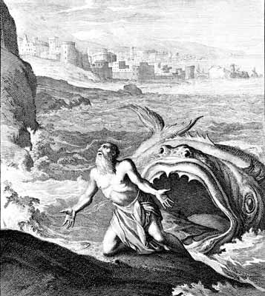

MEANING OF THE NAME:

Jonah means: Dove
Dove seems to have been a traditional symbol of Israel.
Therefore , Jonah symbolizes the Jewish nation as whole in :
1- Their disobedience to God.
2- In its prejudice against the Gentile nations.
3- And in its misunderstandings of God’s purpose and methods?
This book differs from the other eleven in that it is a narrative about a prophet rather than a record of his prophetic utterances.

CONTENTS:
The book falls naturally into two parts :
I- Jonah’s flight from the Lord and from his prophetic mission ( Chaps.1-2)
( Jonah’s “NO” to God and his speedily disaster ).
II- Jonah’s reluctant obedience to God and his subsequent education by God. ( chaps.3-4)
( Jonah’s “YES” to God and thereby new knowledge of God and hi
purpose for the world. )

HISTORICAL AND LITERARY CHARACTER:
Controversy has long raged about whether or not the incidents described in the book actually happened. Did this eighth-century prophet that is mentioned in II Kings did indeed write about a sober piece of history or he simply meant it to be a parable to convey a religious truth about God.

The authenticity of the story is manifested in :
- a Jonah , the son of Amittai actually existed during the period when the Assyrians ruled from the capital city of Nineveh ( II Kings 14:25).
- Jesus accepted as fact the experience of Jonah in the belly of the fish and the conversion of the Ninevites . ( Matt. 12: 40-41)
- Rejection of the historical integrity of the Jonah narrative rests on skepticism and unbelief in the power of the living God.

DATE AND AUTHORSHIP:
Date: Eighth century , about 750 B.C.
( Some believe that since Nineveh no longer existed at that time as it fell in 612 B.C. ; that this book appropriately fits the fifth and the fourth centuries , rather than the eighth, and that the story as a whole is directed to the postexilic situation.

MESSAGE AND SIGNIFICANCE:

I-
- The main teaching of the book is that God loves the Assyrians , all people , and even the animals.
- His attitude is quite different from the Jewish desire for the destruction of foreign nations.
- God’s mercy and love is not for Israel alone.

II-
Another point pertains to God’s chosen instruments , although they try to avoid their assigned mission, they cannot ultimately escape from God, who will follow them , disciplines them, educate them , until they are fit instruments for His service.

This message fits best the postexilic time in Judah , when strong nationalistic , exclusivist emphases were dominant , particularly under Ezra and Nehemiah , where Jewish men were forced to divorce foreign wives and blood purity was highly regarded.

Later however, Nineveh reverted to their wicked ways, and the prophet Nahum was sent to alert them that their proud city would soon fall.

What is the Good Word
“ When my soul fainted within me , I remembered the Lord. “
Jon. 2:7

