INTRODUCTION

In the Hebrew Bible Hosea stands first in the collection of shorter prophetic books known as “ The Twelve “.this collection is now generally called the minor prophets.
The order of these Twelve books is not strictly chronological. Amos for example was earlier than Hosea. But those who put the Hebrew Bible together apparently attempted a rough chronological grouping. Hosea, Joel, Amos, Obadiah, Jonah and Micah were believed to belong to the period of the height of the Assyrian power over Israel and Judah ( 2nd half of the eighth century B.C.). Nahum , Habakkuk and Zephaniah were thought to belong to the period of the end of the Assyrian power , ( the last 3rd of the seventh century). Haggai , Zechariah and Malachi were recognized as belonging to the Persian period ( 6th through 5th centuries ).
It is possible that Hosea was put first in the first group because it is the longest book of that group.

HOSEA

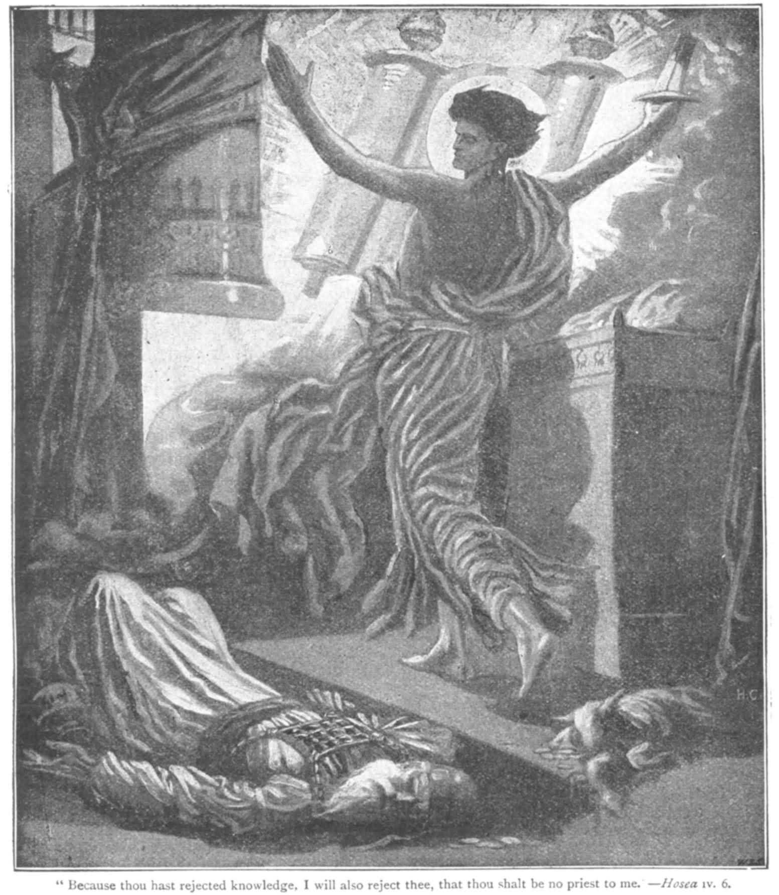

TIMES OF HOSEA:
Hosea carried out his ministry in the Northern Kingdom, during the closing days of the reign of Jeroboam II ( 786-746 ) and for some time after this king’s death. He predominately directed his message toward the situation in the North.
He lived in a turbulent age.
- Jeroboam II expanded the borders of Israel and brought great prosperity to his kingdom , at least to the upper class. The rich however, oppressed the poor. The poor were robbed and generally found no justice in courts.
- Though king and people worshipped Yahweh in great shrines, pagan fertility glorifying Baal , flourished independently and religious decay had set in.

LIFE OF HOSEA:
Hosea apparently died shortly before the fall of the Northern Kingdom.
Little is known of his personal life. We learn that his father’s name is Beeri ( 1:1).
His relationship with his wife Gomer was to him a symbol of Yahweh’s relationship to Israel. In essence , it demonstrates , the fickle lack of devotion Israel showed for God.
At God’s instruction , he married “ an adulterous wife “ who bore him three children, before leaving him to live with other men.
But after leaving Hosea, she sold herself into slavery. God then instructed the prophet to redeem her, not only buying back her freedom, but also expressing love and forgiveness.
It is evident form the high quality of his prophetic statements, that he was an educated man.

THE BOOK= 14 chapters
Hosea’s message: Hosea describes the connection between God and Israel as a marriage relation (1:2 ; 2:16) or as a father –son relationship (11:1). The bond between God and his people began with the exodus from Egypt ( 12:9; 13:4) and issued from God’s love
( 11:1).
The first three chapters of the book describes the prophet’s personal struggles , and the remainder of the book shows how the relationship of the people toward God mirrored the struggling relationship between Gomer and Hosea.
God’s people were about to stray from Him and would need to be forgiven and rescued when no longer able to fend for themselves.

We may conclude this much ,at least: that Hosea had an unfortunate marriage , whatever its exact nature; that he saw a parallel between it and God’s relation to Israel. In fact through his actions in the marital relationship he sought to declare both God’s judgment, (by exposing Israel criminal record against God in chapters 4-10) and his mercy on the nation ( chapters 11-14).

What is the good word

“For I desire steadfast love and not sacrifice, the knowledge of God, rather than burnt offerings.” Hos.6:6

