10-HAGGAI
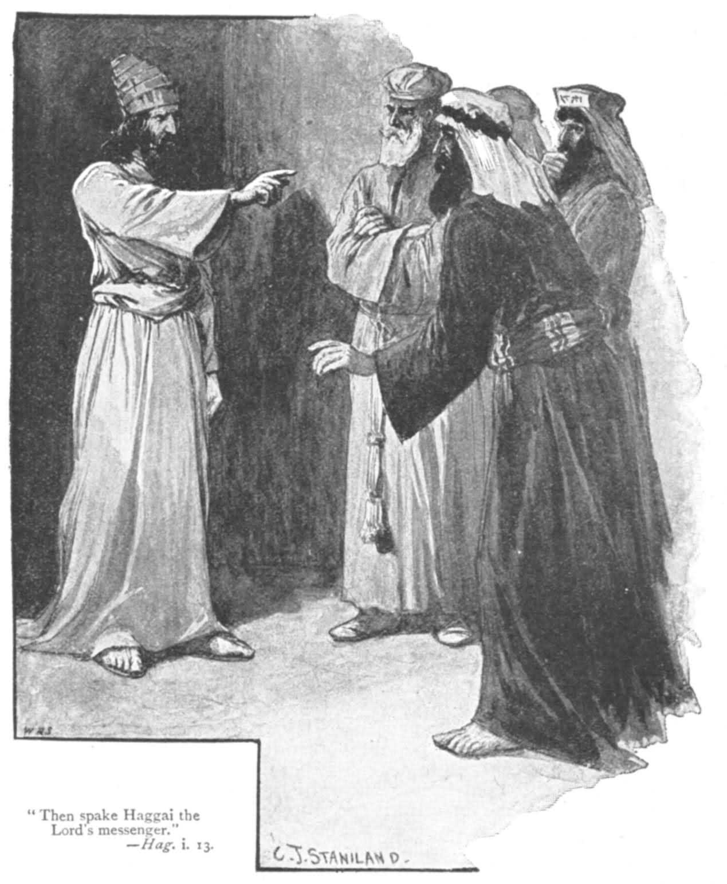

Haggai and Zechariah opened the third period in Hebrew prophecy; the postexilic prophets.
- Before the exile , the prophets warned about the coming punishment of Israel and the nations.
- During the exile , they sought to comfort God’s people and prepare them for a new future in their homeland.
- After the exile , they attempted to stimulate the rebuilding of religious and political life of the restored community according to the Law of God.
( These people were discouraged and apathetic in their relationship with God.)
Therefore , the prophetic word was always shaped by the historical situation. It was never static or stereotyped.

Haggai is the second only to Obadiah in brevity among the Old Testament books.

NAME , DATE HISTORICAL SITUATION:
Haggai: means “ festal” or born on the feast day.
- His prophecies fall within a 4 month period ( August to December) of the second year of Darius I ( 520 B.C.).
- Some of the exiles had been back in Palestine, in an attempt to rebuild community life there. Whether work on the temple was beginning , it is not clear , but apparently did not proceed far.
- Haggai , in 520 , rebuked his hearers for preoccupation with building their own houses and neglect the house of Yahweh. ( 1:4 , 9).
- Dismal economic conditions due to the devastated condition of the country, drought, the hostility of neighbors and the like made sheer survival the central concern and prevented work on the temple.
- Haggai prophetic mission was to stimulate the beginning of temple reconstruction and to keep enthusiasm and activity alive until it was completed.
- He was assisted in this by Zechariah.

CONTENTS:
The book consists of four dated utterances of Haggai :
- Yahweh’s command to the governor, the high priest and the people to begin rebuilding of the temple and their response. ( 1:1-15 ) ( August- September, 520 B.C.)
- Yahweh’s word of encouragement to the builders concerning the future glory of the temple. ( 2: 1-9) ( October 520 B.C.)
- Yahweh’s clarification about certain “ unclean” matters affecting the life and future of the people. ( 2:10-19) ( December 520 B.C.)
- Yahweh’s promise concerning Zerubbabel’s coming role as messianic king.
( 2:20-23) ( December 520 B.C.)

MESSAGE:
Haggai message was centered in the importance of the temple, a task that had languished for 16 years. He lamented the self-centered life style of the returned exiles. He attributed the misfortunes that had befallen the people since their return to their neglect of the proper worship of God in a proper temple. Haggai urged the people to put God first , and things will come out beyond their imagination even , concerning the splendor of the temple itself.

What is the good word?
“ From this day on I will bless you.” Hag.2:19

