8-HABAKKUK

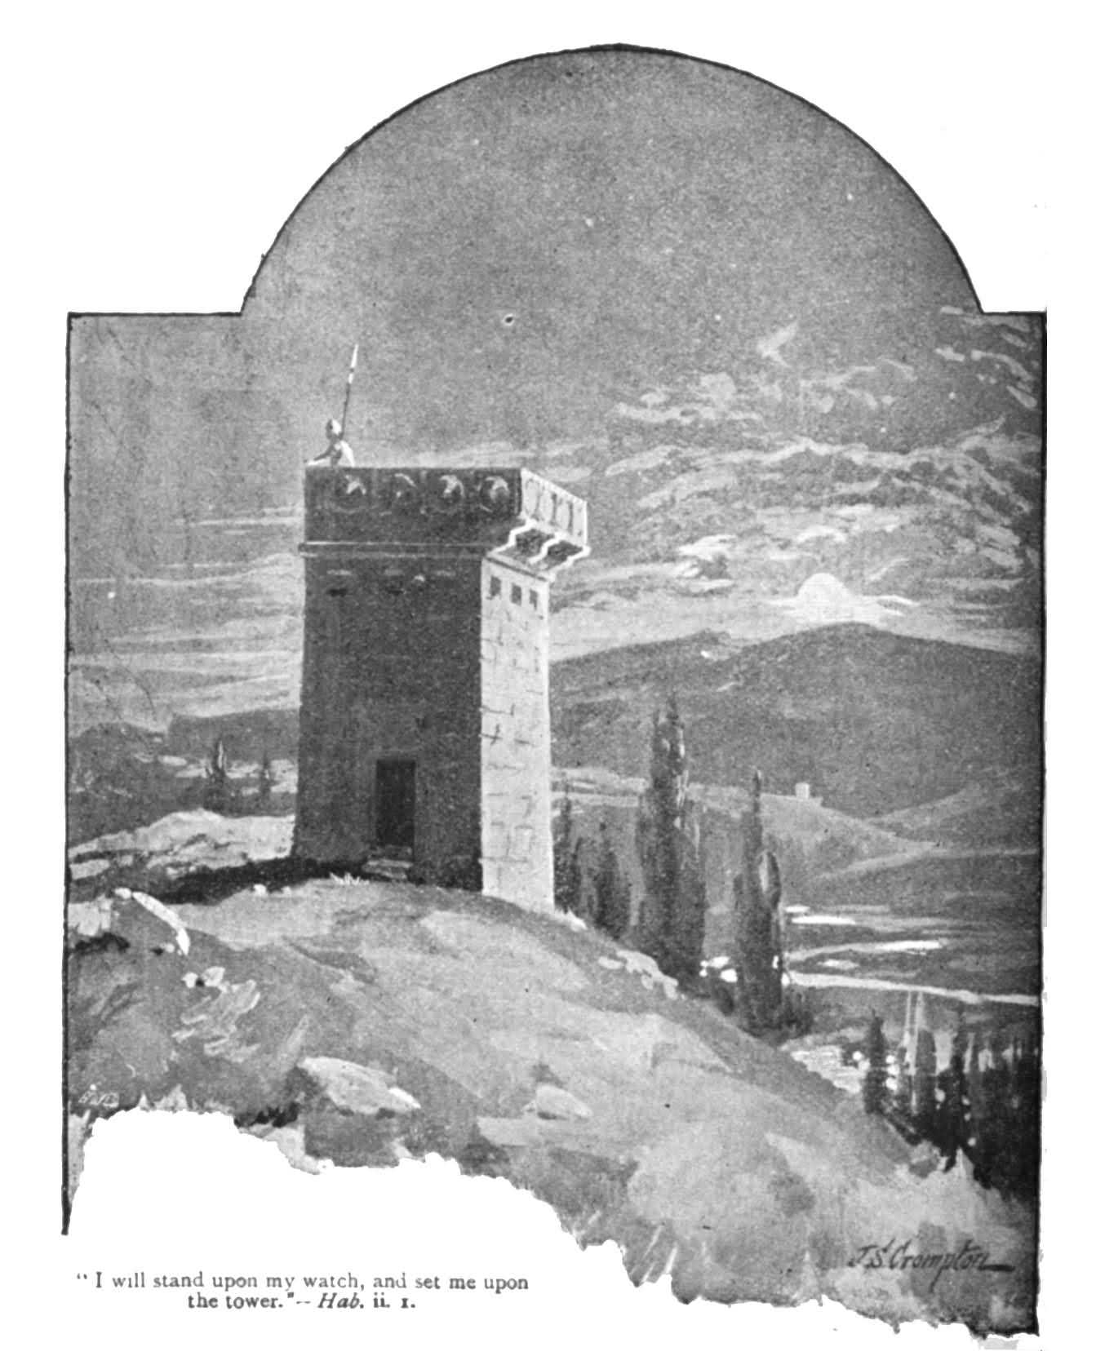

Habakkuk is the first prophet to raise in sharp form the problem of the suffering of righteous Israel at the hands of unrighteous foreigners. The problem arose from Israel’s belief that God rewards the righteous and punishes the unrighteous.
Habakkuk has been called “ the skeptic among the prophet”. While the book begins in doubt, it ends in faith , showing that the prophet in his personal struggle at last found grounds for believing in the justice and goodness of God.

NAME OF THE PROPHET:
Habakkuk is not a Hebrew name. It probably comes from an Akkadian word meaning
“ a garden plant” . Some believe from the musical reference at the conclusion of the book, that he may have been a priest connected with the temple worship in Jerusalem.

CONTENTS AND DATE:
- The book contains mainly a dialogue between the prophet and God. In this respect Habakkuk is like Jeremiah , who often had had arguments with God.

- Although , there are no reference to the reign of a king, evidence indicates a date between the death of the righteous king Josiah ( 609 ) B.C. and early in the wicked reign of king Jehoiakim ( 609- 597 B.C.) ; approximately around he end of the Assyrian rule which was exchanged for the Babylonian rule; both were cruel and financially demanding.

- The book may be conveniently divided into two portions: the problems or perplexity of Habakkuk ( chs. 1 and 2) and the praise of Habakkuk ( ch.3).

MESSAGE:
Question I: Why does God not respond to the wrong and injustice, and sin has
become so prevalent in the land (1:2-4)?
Answer : He is about to respond by using the ruthless Babylon ( Chaldeans ) as a tool
of judgment, on His sinful people. ( 1:5-11)
Question II: Why does God use the wicked Babylonians to punish those more
righteous than themselves. ( 1:12,13) ?.
answer: God has chosen this plan of action , but the Babylonians will have their
turn of woes.( 2:2,3). The just person will live by faith in God
(2:4). Woe to the unrighteous. ( 2:6-20)
THE PRAISE OF HABAKKUK ( 3:1-19)

What is the good word?
“………….in wrath remember mercy “ Hab. 3:2

