3- AMOS

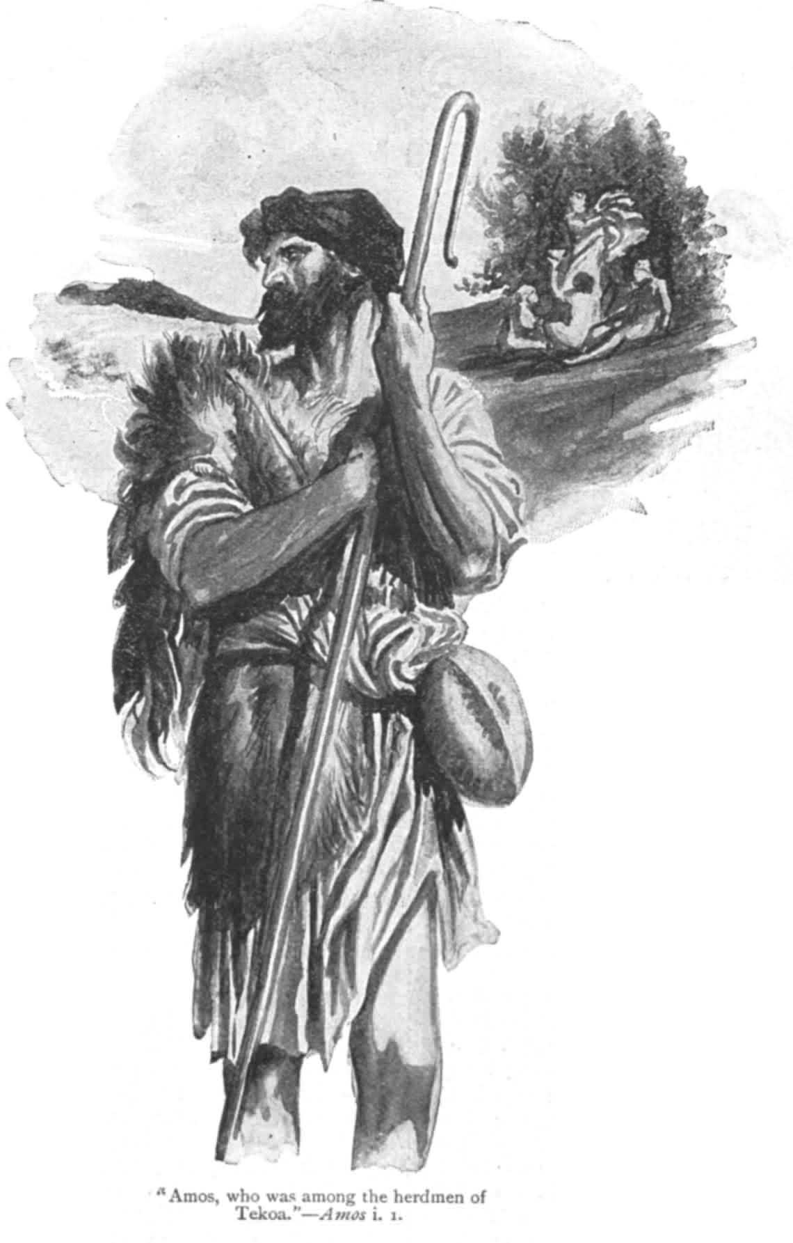

LIFE OF AMOS:
Amos was a shepherd. One of the mightiest preachers of Israel was this shepherd and caretaker of the sycamore ( fig) trees, Amos of Tekoa in the Southern Kingdom.

- He was not a prophet or a prophet son ( 7:14) , that is he was not a professional prophet attached to the court and temple of Jerusalem.
- He was a skilled middle class laborer whom God called to be a prophet. ( 7:15)
- His prophetic ministry was short and apparently limited to the Northern Kingdom, which was not his home country, but he regarded Israel as one people.

TIMES OF AMOS

The writing of the book dates to the reigns of Uzziah of Judah and Jeroboam II of Israel , probably around 760-750 B.C.

- Both kings defeated their enemies, expanded their borders, achieved internal stability and engaged in external commerce.
- But even though, things were outwardly good , the inner spiritual condition of the people were rapidly deteriorating.
- Moreover , in the midst of prosperity , there was poverty. The wealthy grew richer by exploiting the poor through sharp lending practices ( 2:8a) , fines( 2:8b) and bribing judges in court ( 2 :6-7a; 12:6)
- They worshipped other Gods and participated in rituals that included drunkenness, violence and sexuality.

MESSAGE OF AMOS:
Amos warned of doom on the Northern Kingdom and its king and advised them of captivity to come. He was so emphatic which led the high priest to rebuke him and he was accused of treason. The high priest banished Amos apparently by command of Jeroboam II.
He then returned to Tekoa. Whether he had further prophetic ministry in Judah is unknown, but is unlikely.
His career as a prophet may have lasted only two to three months.

His message may be summarized into :
- The god of Israel is the lord of the whole earth. Though he stands a special relationship with Israel , his interest and activity is directed toward other nations as well. ( 9:7). He holds ALL people accountable to their actions , Israel and their enemies.
- He is a God of righteousness. He is forever against nations and individuals who do wrong. “ They do not know how to do right. “ ( 3:10)
- God’s requirements are moral. Sacrificial rites do not bring his favor. Justice to one another is what He wants from man and honest worship.
- God supports those who do right and punishes those who do evil. He has no favorites.

AMOS’ SIGNIFICANCE:
Amos marks the beginning of a new era in the history of religion. No prophet before him saw so clearly the universal sovereignty of Israel’s God and his unwavering requirement of right conduct by all men , especially those standing in closet relationship to him.(3 ;2 )

What is the good word:
“ Come to the LORD and live” Amos 5:6

