ST.Philopateer Coptic Orthodox Church Of Dallas
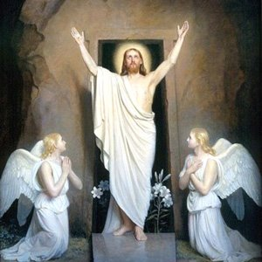
Pre-school week 1- Pentecost
JESUS CHRIST IS RISEN!
Bible Reference: Mathew 28
Verse: “He is risen, as He said.”(Mathew 28:6)

1-What is the big feast we had last Sunday?
A-Feast of the cross.
B-Resurrection.
c-Nativity feast.

2-Our LORD Jesus Christ rose from the dead on :
A-Third day.
B-First day.
C-Jesus never died.

3-Who rolled the big stone in front of Jesus tomb?
A-Mary Magdalene.
B-The Angel.
c-The soldiers.

“Christ is risen! Truly, He is risen!”

