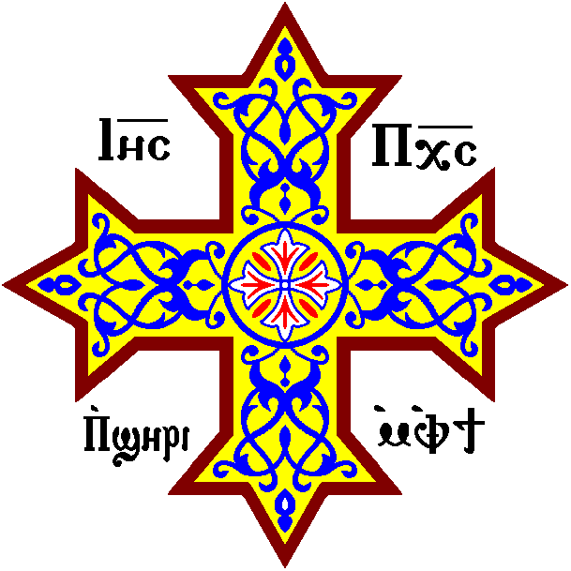
St. Philopateer Coptic Orthodox Church of Dallas
Kindergarten Week 1-The Happiest Day. 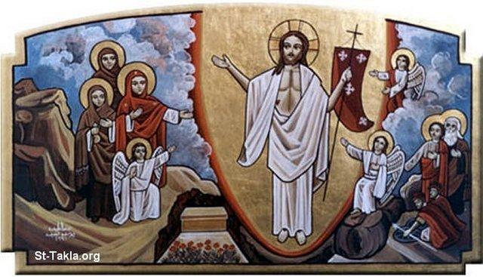

References: Luke 24:1-12, Matthew 28:1-8, Mark 16:1-8, John 20:1-10
Bible verse: “He is not here, but is risen” (Luke 24:6)
Homework Questions:
- How many days did Jesus spend in the tomb?
- 1 day.
- 2 days.
- 3 days.

2-what did the Maries find when they arrived at the tomb?
a-The big stone was removed.
b- There was two stones instead of one.

3-what did the angel tell the Maries?
a-Don’t cry Jesus is risen.
b-I am so sad too.
c-I don’t know where is he.

4-What did the Maries do after they knew Jesus was alive?
a-They were still crying.
b-They went and told Jesus friends and disciples.

